**Task 1: Deploy the on-premises environment**

On-Premises Environment has been deployed in East Us and Resource Group Name is **SmartHotelHostRG with the help of template** **SmartHotelHost.json**

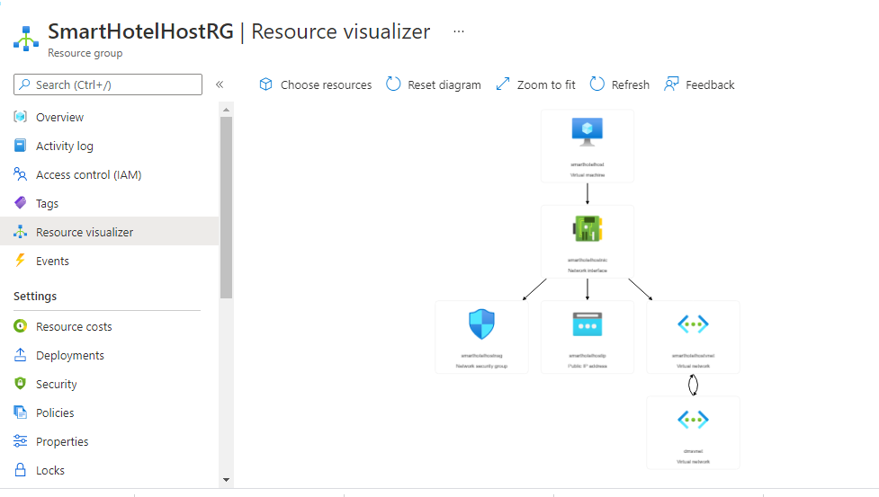

**On-premises**

|  |  |  |
| --- | --- | --- |
| NAME | TYPE | LOCATION |
| DMSvnet | Virtual network | East US |
| SmartHotelHost | Virtual machine | East US |
| SmartHotelHost_DataDisk | Disk | East US |
| SmartHotelHost_OsDisk | Disk | East US |
| smarthotelhostip | Public IP address | East US |
| smarthotelhostnic | Network interface | East US |
| smarthotelhostnsg | Network security group | East US |
| smarthotelhostvnet | Virtual network | East US |

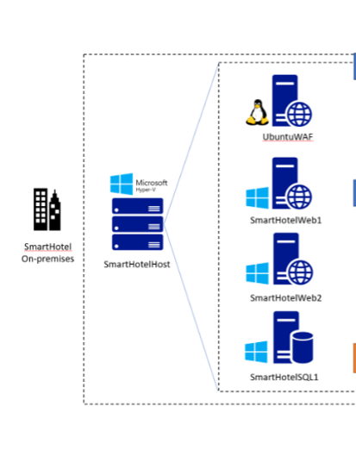

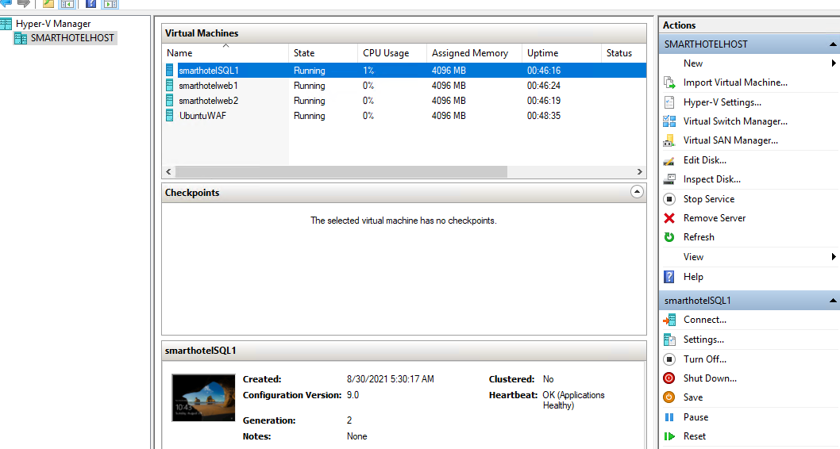

### Task 2: Verify the on-premises environment

*Task summary*

Verified the on-premises environment by accessing IP 13.92.59.191 (SmartHotelHost)

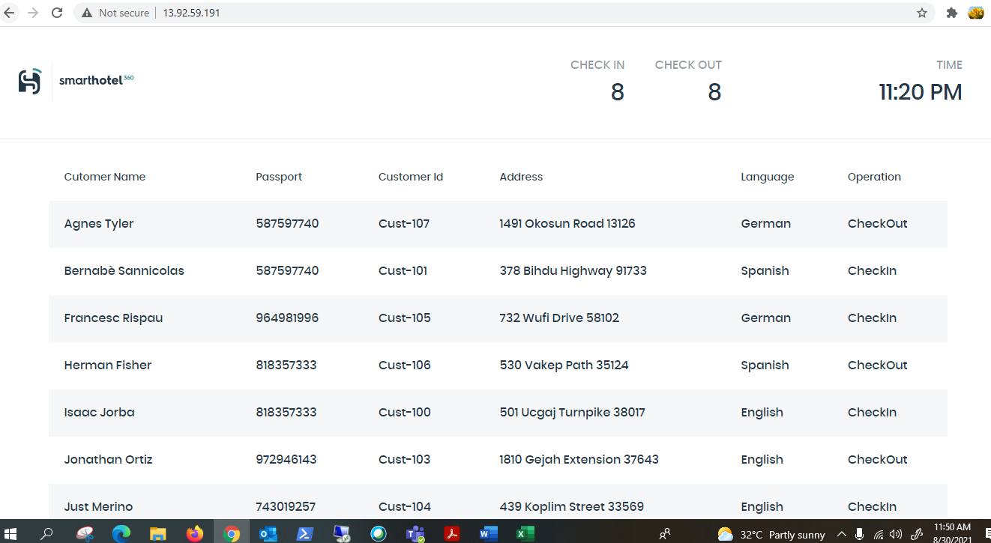

[Line-of-business application migration hands-on lab step-by-step](https://github.com/microsoft/MCW-Line-of-business-application-migration/blob/master/Hands-on%20lab/HOL%20step-by%20step%20-%20Line-of-business%20application%20migration.md#line-of-business-application-migration-hands-on-lab-step-by-step)

[Exercise 1: Discover and assess the on-premises environment](https://github.com/microsoft/MCW-Line-of-business-application-migration/blob/master/Hands-on%20lab/HOL%20step-by%20step%20-%20Line-of-business%20application%20migration.md#exercise-1-discover-and-assess-the-on-premises-environment)

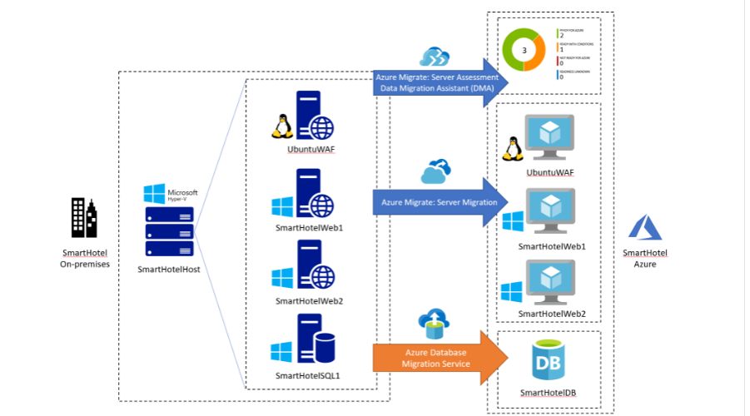

* + [Task 1: Create the Azure Migrate project and add assessment and migration tools](https://github.com/microsoft/MCW-Line-of-business-application-migration/blob/master/Hands-on%20lab/HOL%20step-by%20step%20-%20Line-of-business%20application%20migration.md#task-1-create-the-azure-migrate-project-and-add-assessment-and-migration-tools)

*Task summary*

1 . In this task, created the Azure Migrate project and selected the assessment and migration tools.

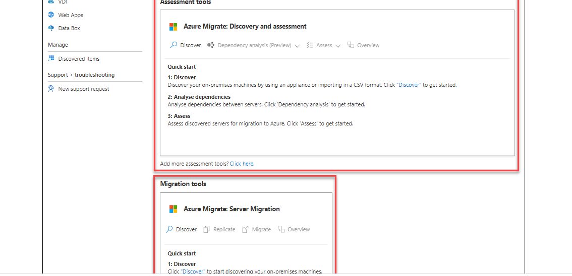

* + [Task 2: Deploy the Azure Migrate appliance](https://github.com/microsoft/MCW-Line-of-business-application-migration/blob/master/Hands-on%20lab/HOL%20step-by%20step%20-%20Line-of-business%20application%20migration.md#task-2-deploy-the-azure-migrate-appliance)

*Task summary*

2 . In this task, deployed and configured the Azure Migrate appliance in the on-premises Hyper-V environment. This appliance communicates with the Hyper-V server to gather configuration and performance data about my on-premises VMs, and returns that data to Azure Migrate project.

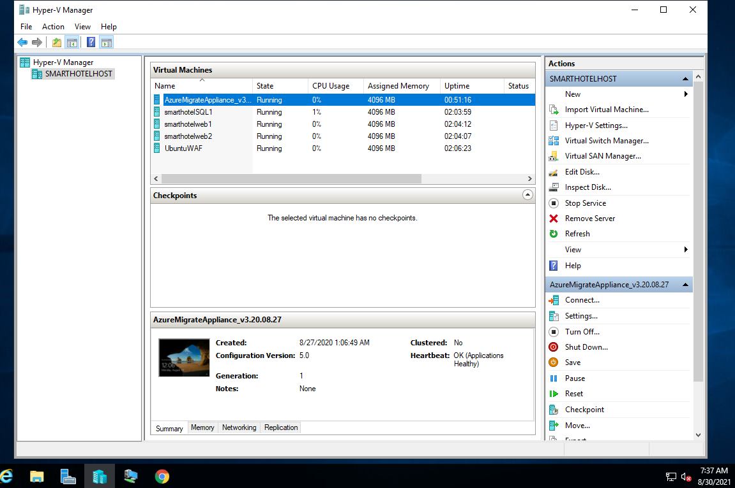

* + [Task 3: Configure the Azure Migrate appliance](https://github.com/microsoft/MCW-Line-of-business-application-migration/blob/master/Hands-on%20lab/HOL%20step-by%20step%20-%20Line-of-business%20application%20migration.md#task-3-configure-the-azure-migrate-appliance)

#### Task summary

In this task Azure Migrate appliance has been configured and used to complete the discovery phase of the migration assessment.

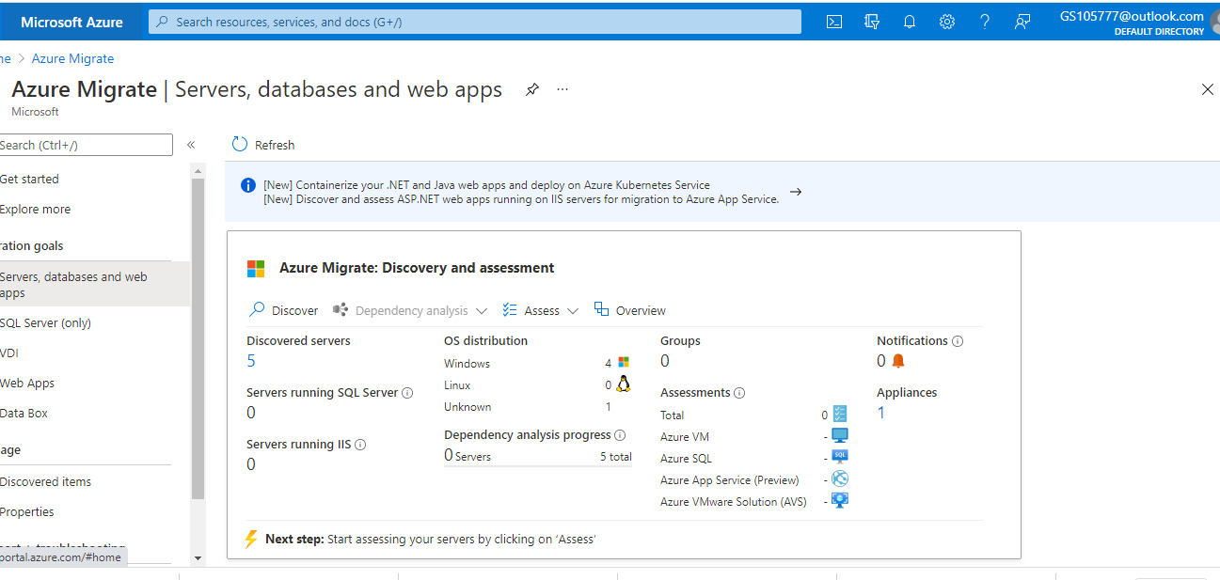

* + [Task 4: Create a migration assessment](https://github.com/microsoft/MCW-Line-of-business-application-migration/blob/master/Hands-on%20lab/HOL%20step-by%20step%20-%20Line-of-business%20application%20migration.md#task-4-create-a-migration-assessment)

#### Task summary

Azure Migrate appliance in the on-premises Hyper-V environment has been configured and started the migration assessment discovery process.

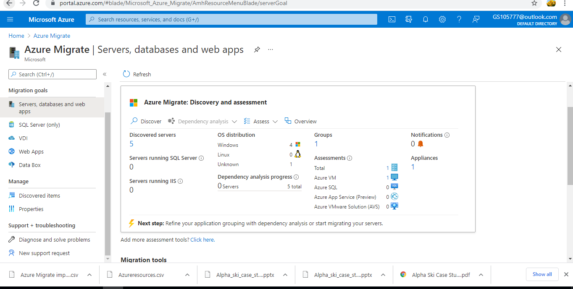

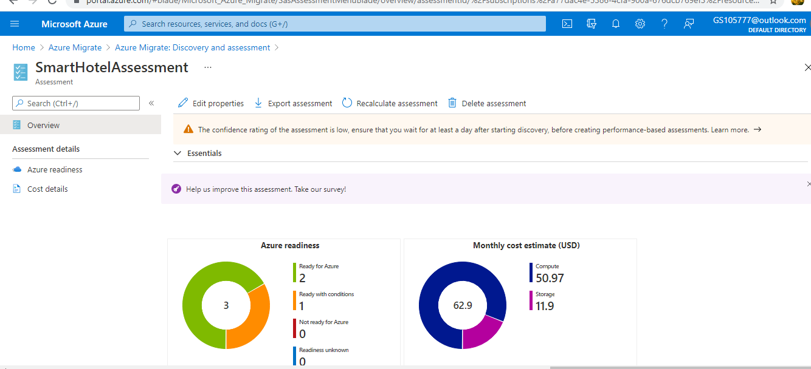

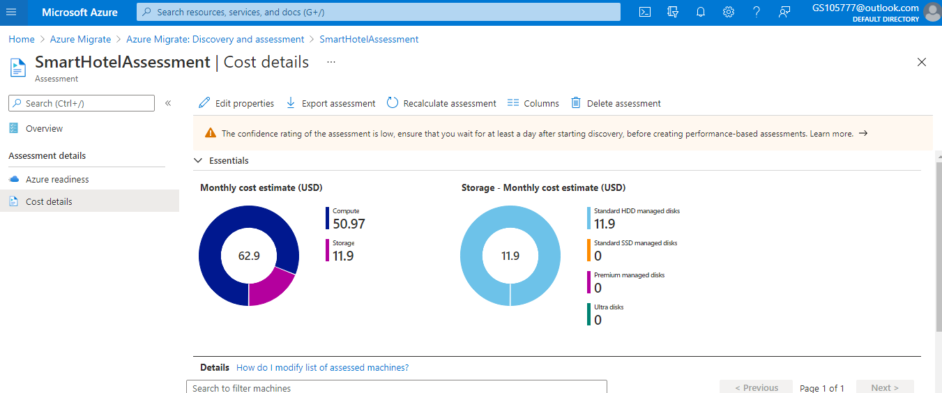

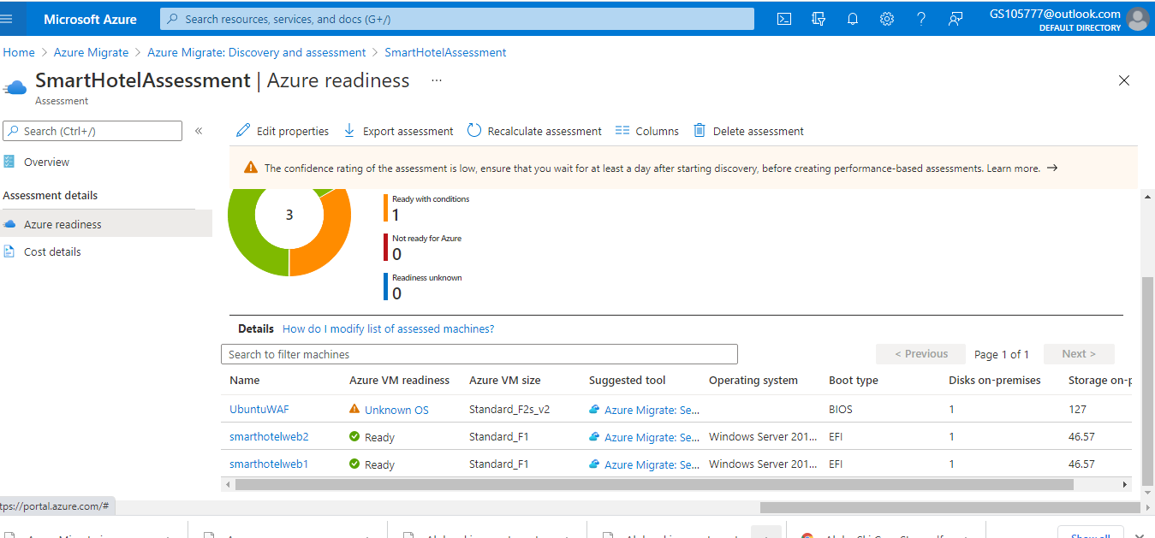

* + [Task 5: Configure dependency visualization](https://github.com/microsoft/MCW-Line-of-business-application-migration/blob/master/Hands-on%20lab/HOL%20step-by%20step%20-%20Line-of-business%20application%20migration.md#task-5-configure-dependency-visualization)

For deeper analysis, the Microsoft Monitoring Agent and Dependency Agent will be installed on the VMs, enabling the Azure Migrate dependency visualization

* When migrating a workload to Azure, it is important to understand all workload dependencies. A broken dependency could mean that the application doesn't run properly in Azure, perhaps in hard-to-detect ways. Some dependencies, such as those between application tiers, are obvious. Other dependencies, such as DNS lookups, Kerberos ticket validation or certificate revocation checks, are not.
* In this task, you will configure the Azure Migrate dependency visualization feature. This requires you to first create a Log Analytics workspace, and then to deploy agents on the to-be-migrated VMs.
* 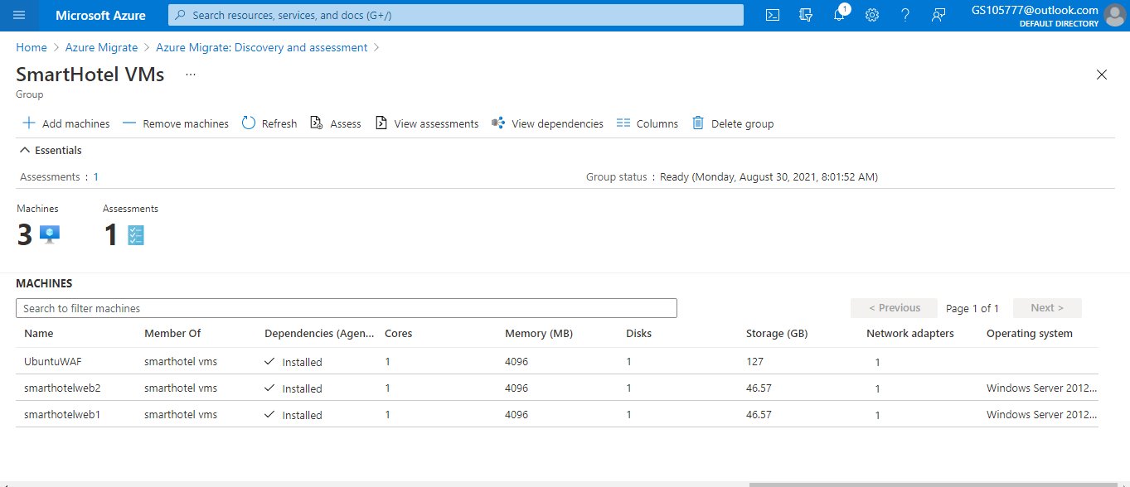
  + [Task 6: Explore dependency visualization](https://github.com/microsoft/MCW-Line-of-business-application-migration/blob/master/Hands-on%20lab/HOL%20step-by%20step%20-%20Line-of-business%20application%20migration.md#task-6-explore-dependency-visualization)

In this task, you will explore the dependency visualization feature of Azure Migrate. This feature uses data gathered by the dependency agent you installed in Task 5.

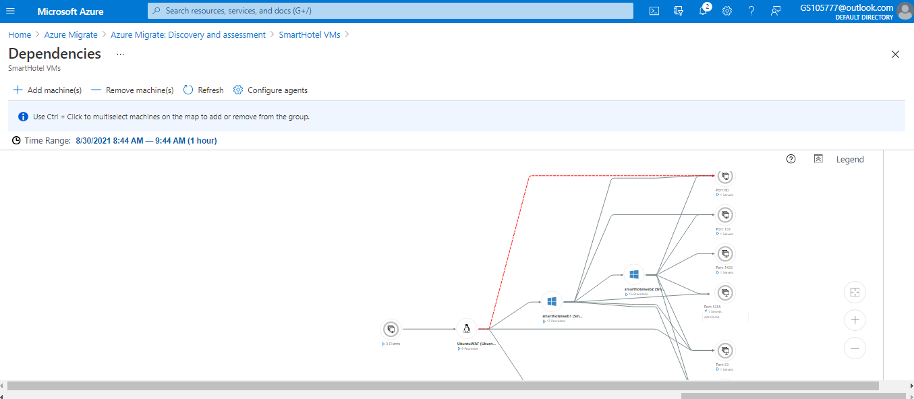

## Exercise 2: Migrate the Application Database

In this exercise you will migrate the application database from the on-premises Hyper-V virtual machine to a new database hosted in the Azure SQL Database service. You will use the Azure Database Migration Service to complete the migration, which uses the Microsoft Data Migration Assistant for the database assessment and schema migration phases.

* + [Task 1: Register the Microsoft.DataMigration resource provider](https://github.com/microsoft/MCW-Line-of-business-application-migration/blob/46a7040bc2f5f45eda2e66f229055f597657a9ee/Hands-on%20lab/HOL%20step-by%20step%20-%20Line-of-business%20application%20migration.md#task-1-register-the-microsoftdatamigration-resource-provider)

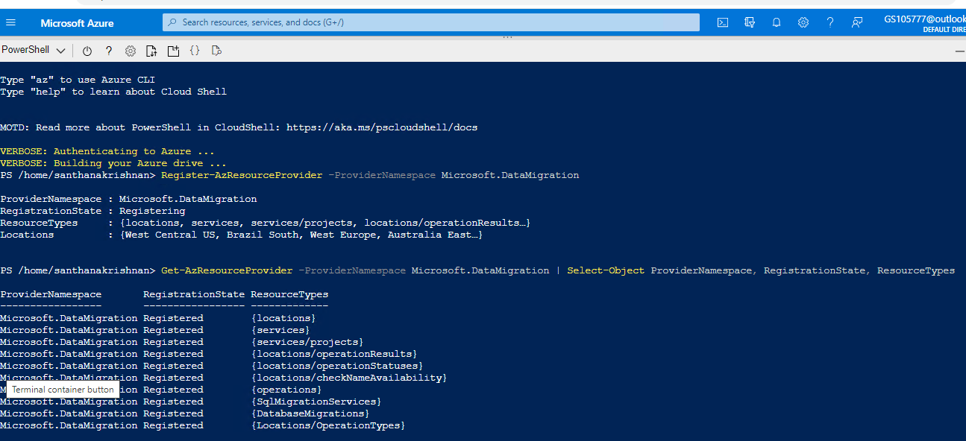

* + [Task 2: Create an Azure SQL Database](https://github.com/microsoft/MCW-Line-of-business-application-migration/blob/46a7040bc2f5f45eda2e66f229055f597657a9ee/Hands-on%20lab/HOL%20step-by%20step%20-%20Line-of-business%20application%20migration.md#task-2-create-an-azure-sql-database)

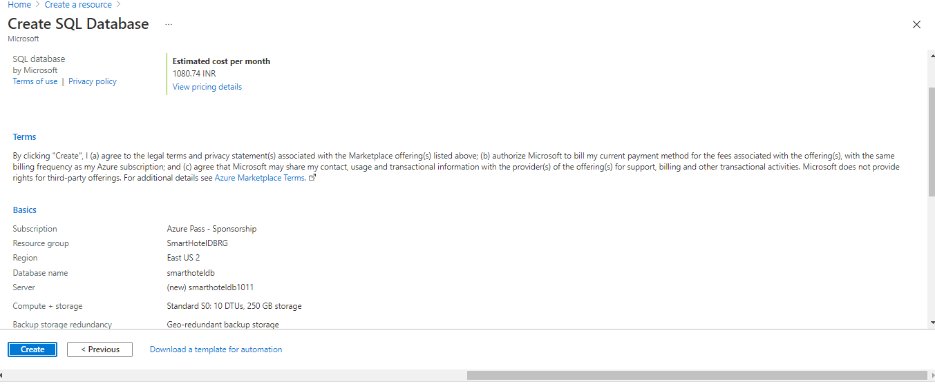

* + [Task 3: Create the Database Migration Service](https://github.com/microsoft/MCW-Line-of-business-application-migration/blob/46a7040bc2f5f45eda2e66f229055f597657a9ee/Hands-on%20lab/HOL%20step-by%20step%20-%20Line-of-business%20application%20migration.md#task-3-create-the-database-migration-service)

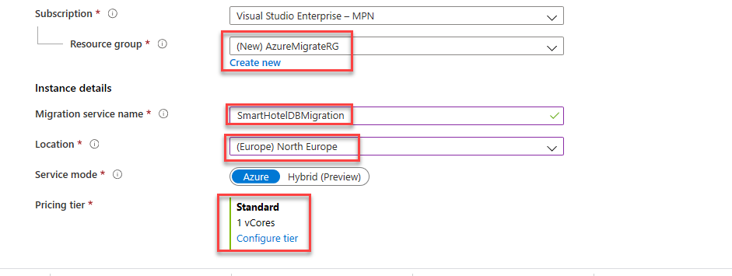

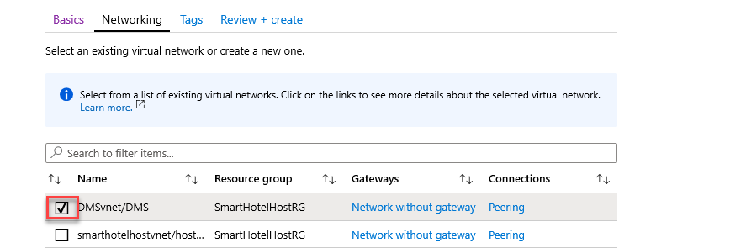

* + [Task 4: Assess the on-premises database using Data Migration Assistant](https://github.com/microsoft/MCW-Line-of-business-application-migration/blob/46a7040bc2f5f45eda2e66f229055f597657a9ee/Hands-on%20lab/HOL%20step-by%20step%20-%20Line-of-business%20application%20migration.md#task-4-assess-the-on-premises-database-using-data-migration-assistant)

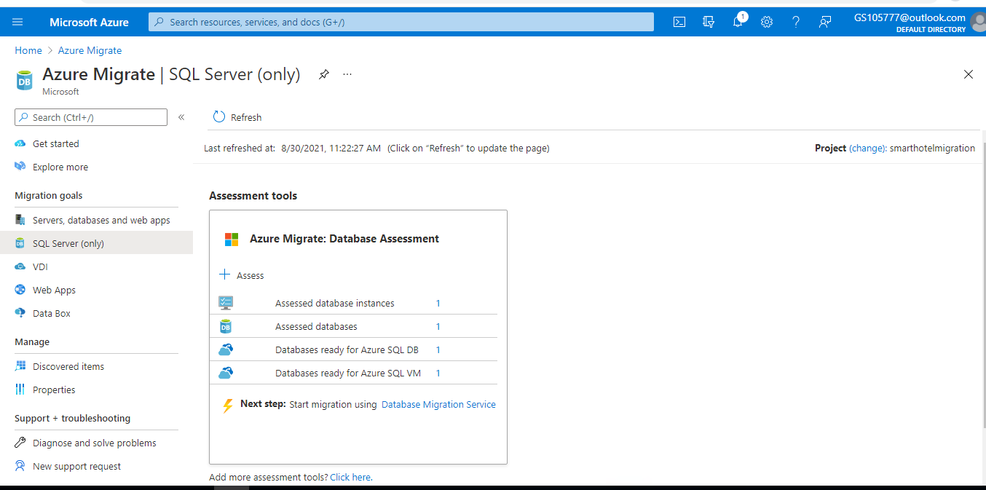

* + [Task 5: Create a DMS migration project](https://github.com/microsoft/MCW-Line-of-business-application-migration/blob/46a7040bc2f5f45eda2e66f229055f597657a9ee/Hands-on%20lab/HOL%20step-by%20step%20-%20Line-of-business%20application%20migration.md#task-5-create-a-dms-migration-project)

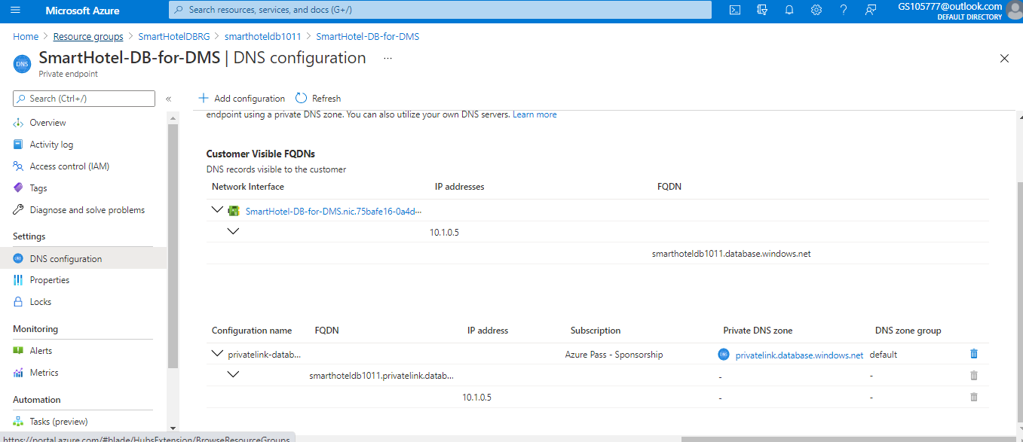

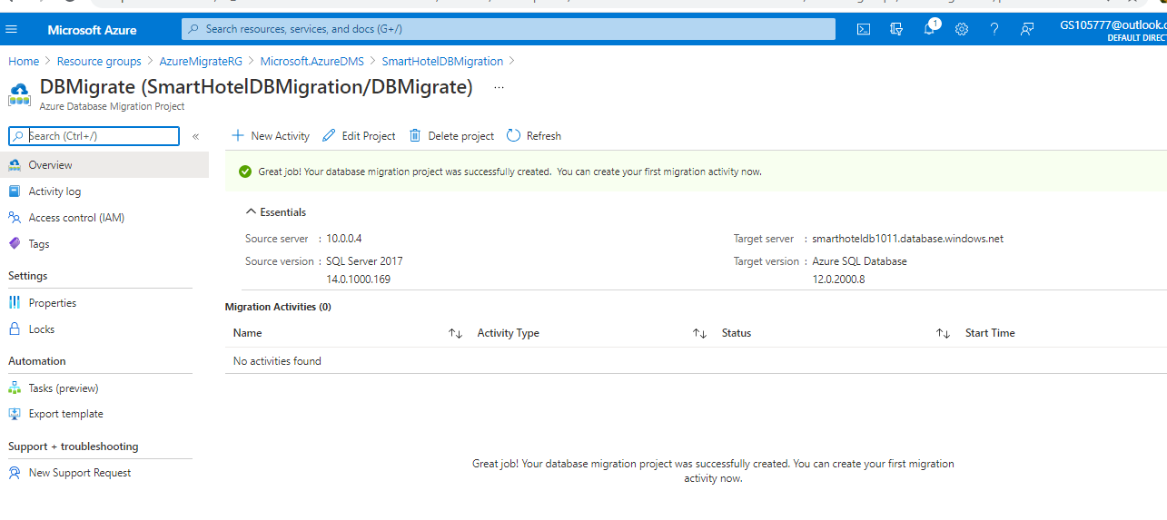

* + [Task 6: Migrate the database schema](https://github.com/microsoft/MCW-Line-of-business-application-migration/blob/46a7040bc2f5f45eda2e66f229055f597657a9ee/Hands-on%20lab/HOL%20step-by%20step%20-%20Line-of-business%20application%20migration.md#task-6-migrate-the-database-schema)

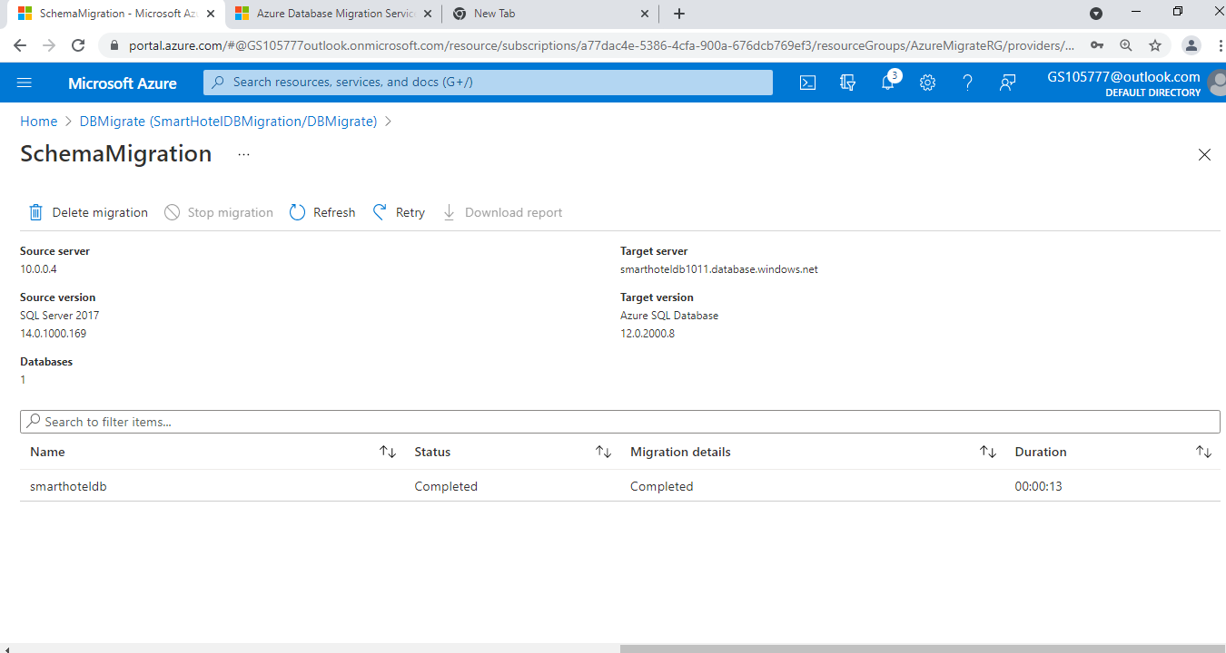

* + [Task 7: Migrate the on-premises data](https://github.com/microsoft/MCW-Line-of-business-application-migration/blob/46a7040bc2f5f45eda2e66f229055f597657a9ee/Hands-on%20lab/HOL%20step-by%20step%20-%20Line-of-business%20application%20migration.md#task-7-migrate-the-on-premises-data)

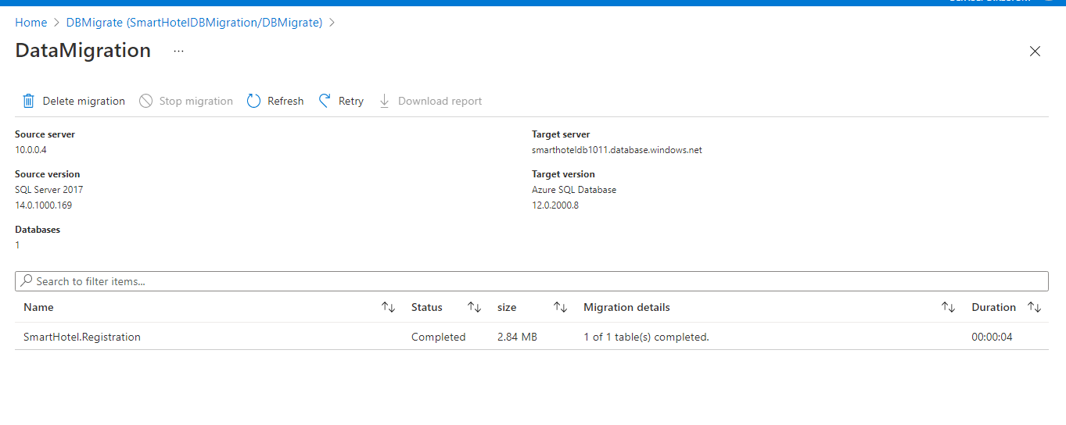

* [Exercise 3: Migrate the application and web tiers using Azure Migrate: Server Migration](https://github.com/microsoft/MCW-Line-of-business-application-migration/blob/46a7040bc2f5f45eda2e66f229055f597657a9ee/Hands-on%20lab/HOL%20step-by%20step%20-%20Line-of-business%20application%20migration.md#exercise-3-migrate-the-application-and-web-tiers-using-azure-migrate-server-migration)

In this exercise you will migrate the web tier and application tiers of the application from on-premises to Azure using Azure Migrate: Server Migration.

Having migrated the virtual machines, you will reconfigure the application tier to use the application database hosted in Azure SQL. This will enable you to verify that the migration application is working end-to-end.

* + [Task 1: Create a Storage Account](https://github.com/microsoft/MCW-Line-of-business-application-migration/blob/46a7040bc2f5f45eda2e66f229055f597657a9ee/Hands-on%20lab/HOL%20step-by%20step%20-%20Line-of-business%20application%20migration.md#task-1-create-a-storage-account)

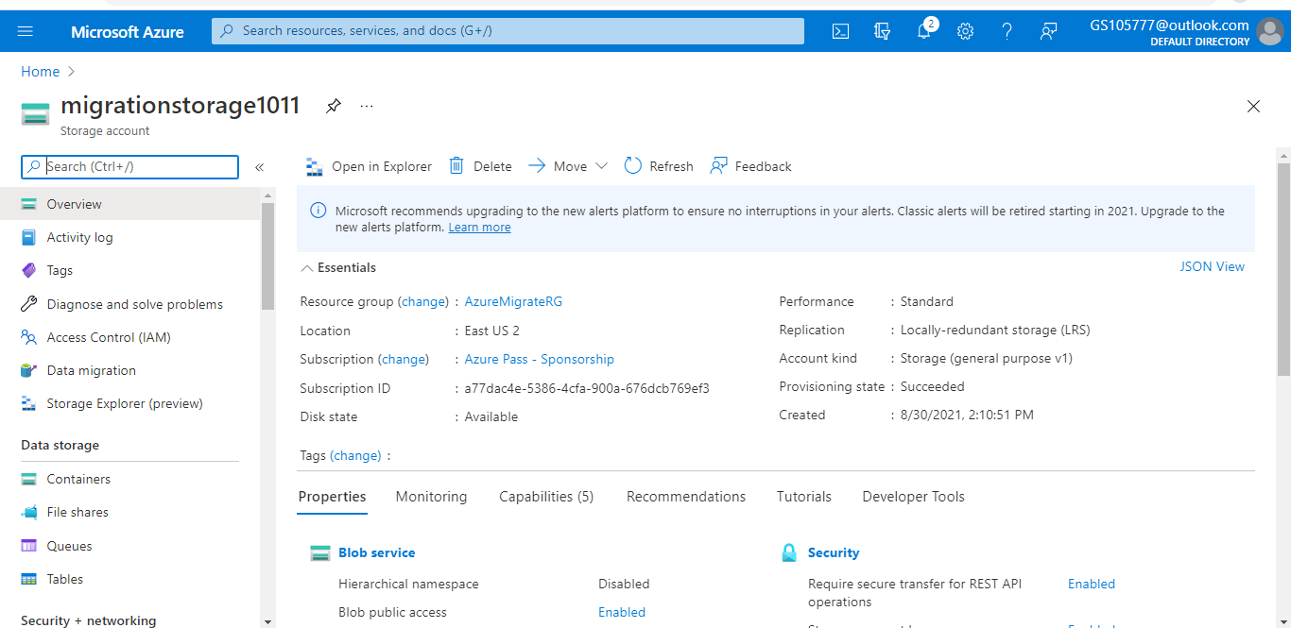

* + [Task 2: Create a Virtual Network](https://github.com/microsoft/MCW-Line-of-business-application-migration/blob/46a7040bc2f5f45eda2e66f229055f597657a9ee/Hands-on%20lab/HOL%20step-by%20step%20-%20Line-of-business%20application%20migration.md#task-2-create-a-virtual-network)

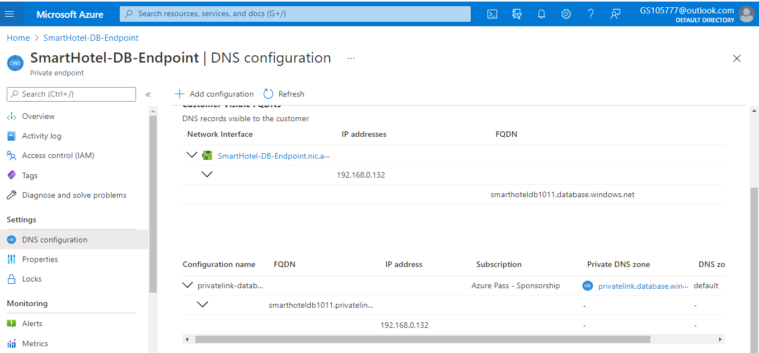

* + [Task 3: Register the Hyper-V Host with Azure Migrate: Server Migration](https://github.com/microsoft/MCW-Line-of-business-application-migration/blob/46a7040bc2f5f45eda2e66f229055f597657a9ee/Hands-on%20lab/HOL%20step-by%20step%20-%20Line-of-business%20application%20migration.md#task-3-register-the-hyper-v-host-with-azure-migrate-server-migration)

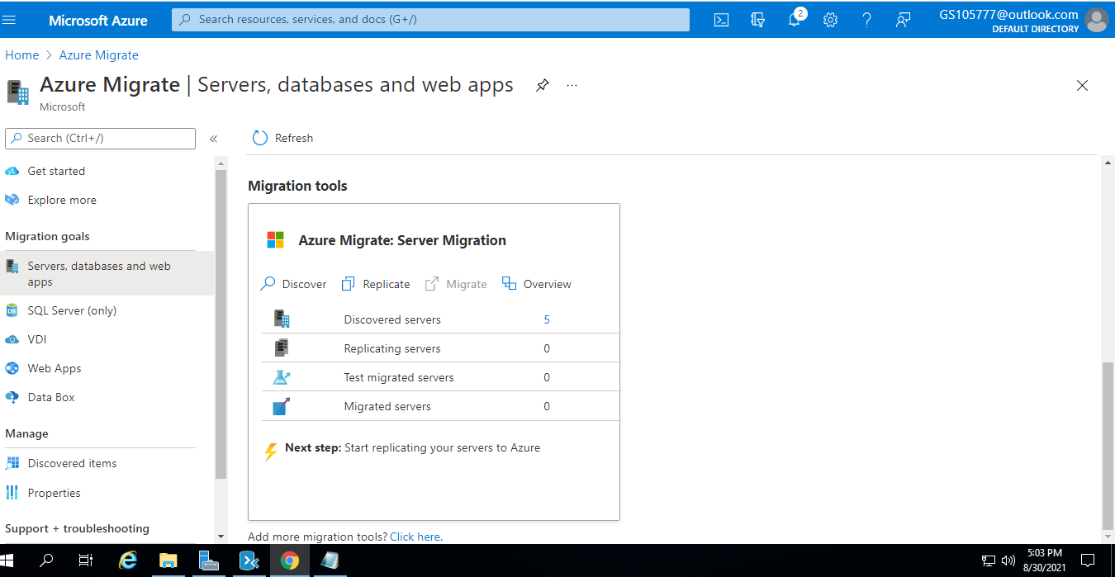

* + [Task 4: Enable Replication from Hyper-V to Azure Migrate](https://github.com/microsoft/MCW-Line-of-business-application-migration/blob/46a7040bc2f5f45eda2e66f229055f597657a9ee/Hands-on%20lab/HOL%20step-by%20step%20-%20Line-of-business%20application%20migration.md#task-4-enable-replication-from-hyper-v-to-azure-migrate)

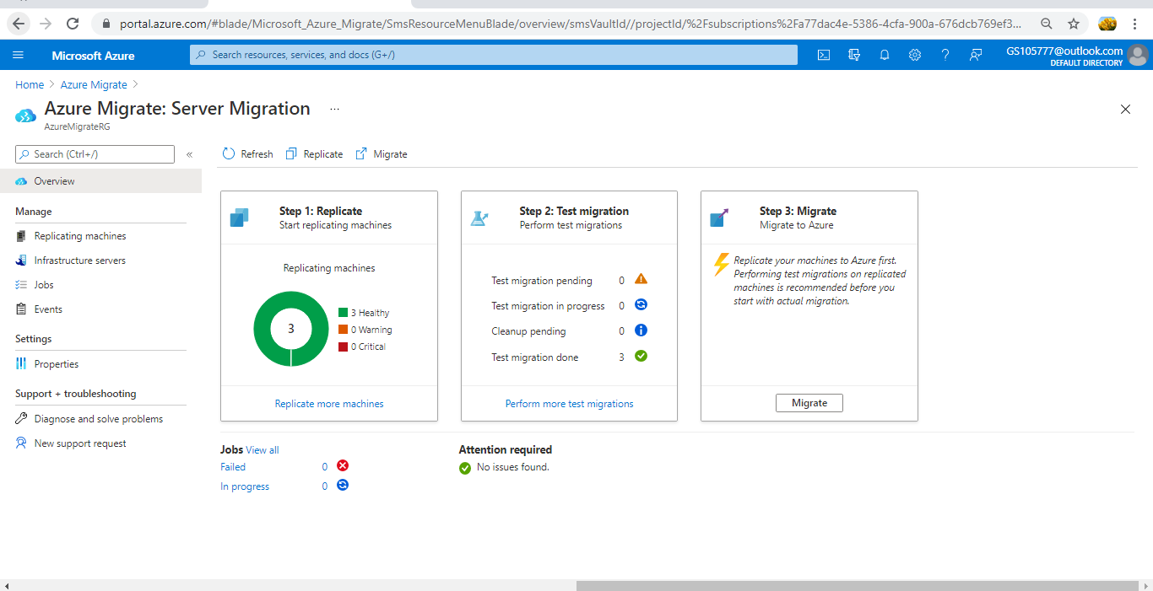

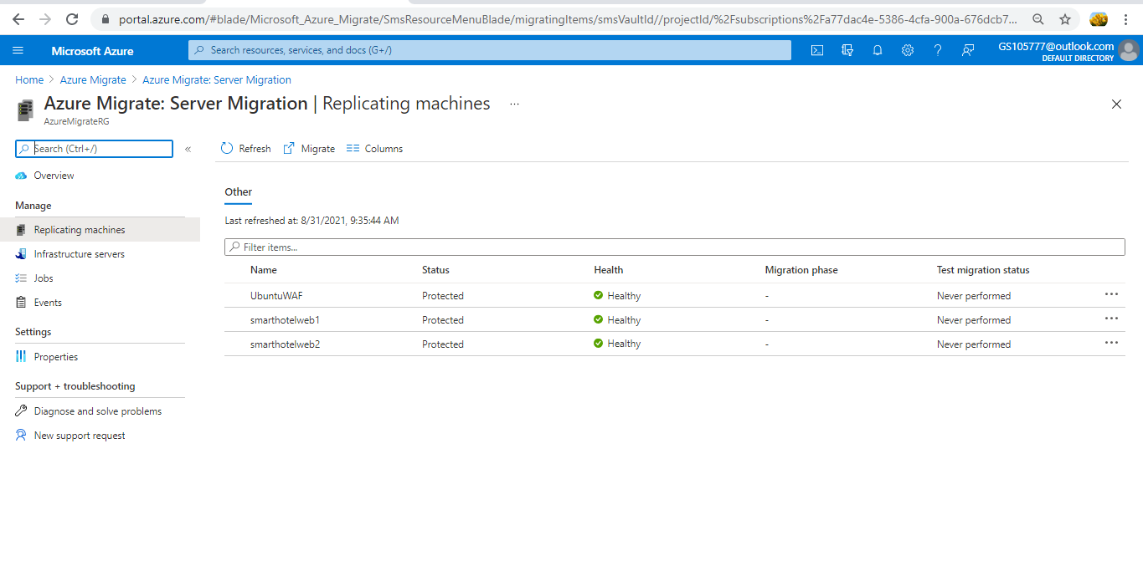

* + [Task 5: Configure static internal IP addresses for each VM](https://github.com/microsoft/MCW-Line-of-business-application-migration/blob/46a7040bc2f5f45eda2e66f229055f597657a9ee/Hands-on%20lab/HOL%20step-by%20step%20-%20Line-of-business%20application%20migration.md#task-5-configure-static-internal-ip-addresses-for-each-vm)

In this task I have modified the settings for each replicated VM to use a static private IP address that matches the on-premises IP addresses for that machine

* For **smarthotelweb1** use private IP address **192.168.0.4**
* For **smarthotelweb2** use private IP address **192.168.0.5**
* For **UbuntuWAF** use private IP address **192.168.0.8**
  + [Task 6: Server migration](https://github.com/microsoft/MCW-Line-of-business-application-migration/blob/46a7040bc2f5f45eda2e66f229055f597657a9ee/Hands-on%20lab/HOL%20step-by%20step%20-%20Line-of-business%20application%20migration.md#task-6-server-migration)

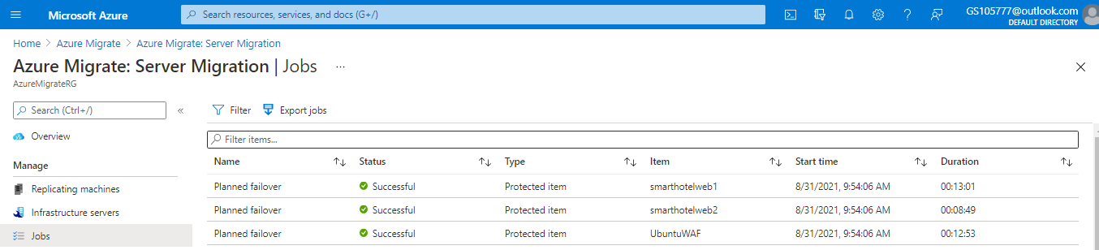

After Migration

Navigate to the **SmartHotelRG** resource group and check that the VM, network interface, and disk resources have been created for each of the virtual machines being migrated.

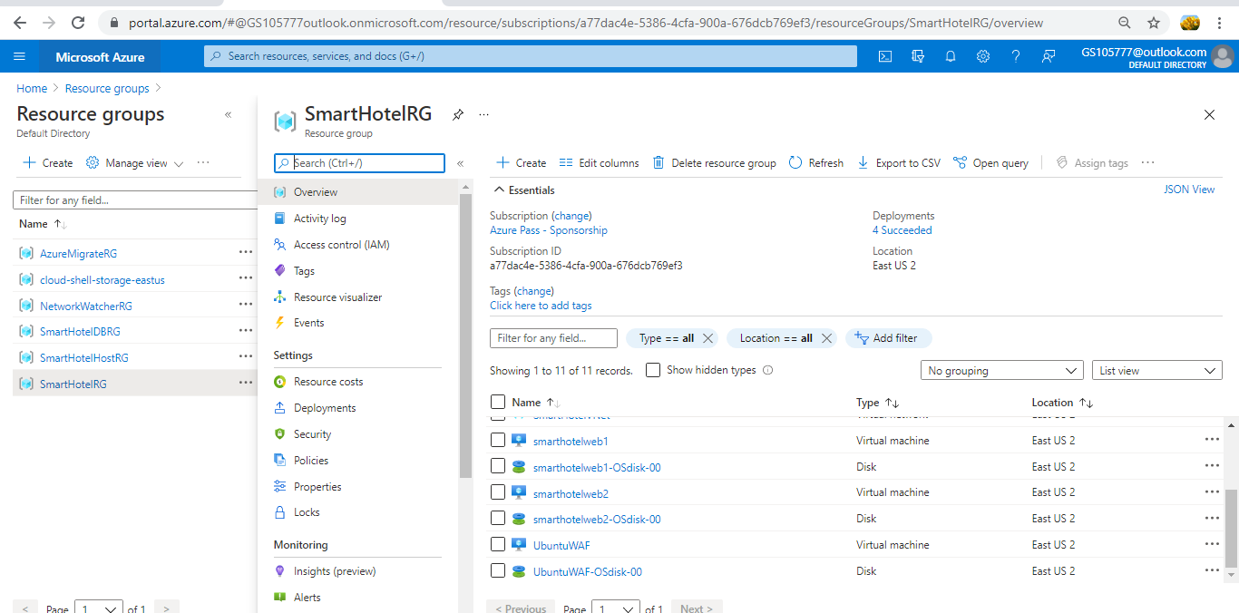

* + [Task 7: Enable Azure Bastion](https://github.com/microsoft/MCW-Line-of-business-application-migration/blob/46a7040bc2f5f45eda2e66f229055f597657a9ee/Hands-on%20lab/HOL%20step-by%20step%20-%20Line-of-business%20application%20migration.md#task-7-enable-azure-bastion)

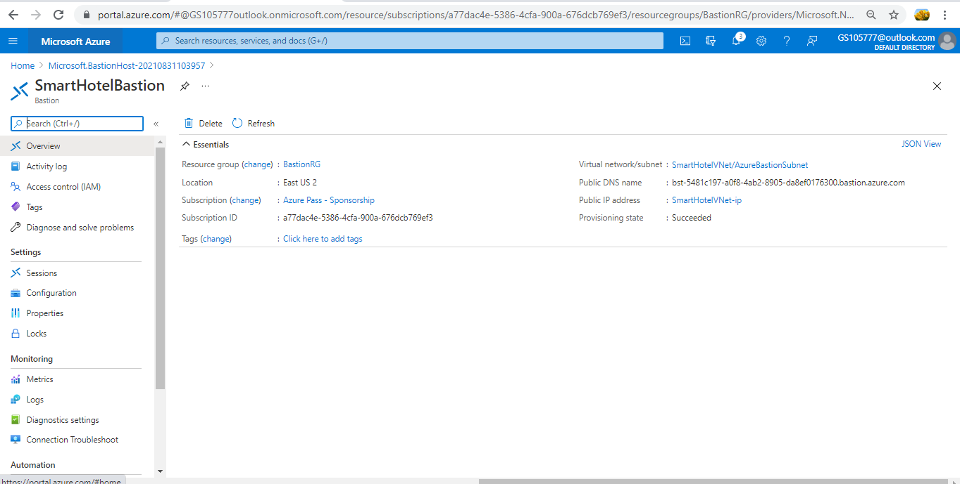

* + [Task 8: Configure the database connection](https://github.com/microsoft/MCW-Line-of-business-application-migration/blob/46a7040bc2f5f45eda2e66f229055f597657a9ee/Hands-on%20lab/HOL%20step-by%20step%20-%20Line-of-business%20application%20migration.md#task-8-configure-the-database-connection)

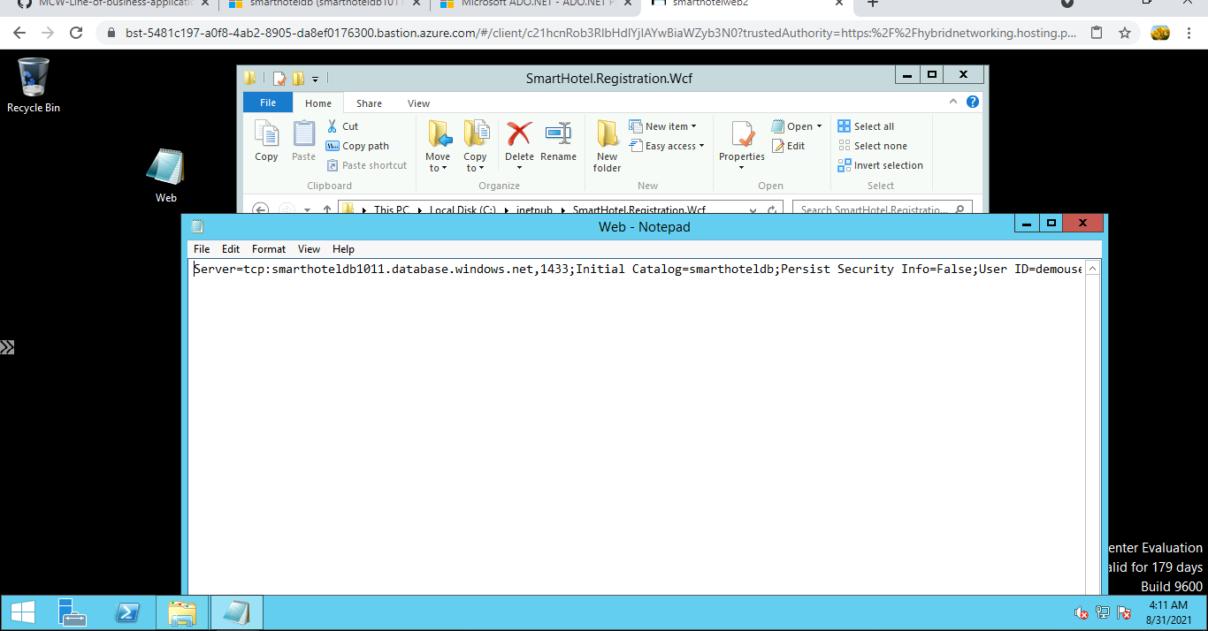

* + [Task 9: Configure the public IP address and test the SmartHotel application](https://github.com/microsoft/MCW-Line-of-business-application-migration/blob/46a7040bc2f5f45eda2e66f229055f597657a9ee/Hands-on%20lab/HOL%20step-by%20step%20-%20Line-of-business%20application%20migration.md#task-9-configure-the-public-ip-address-and-test-the-smarthotel-application)

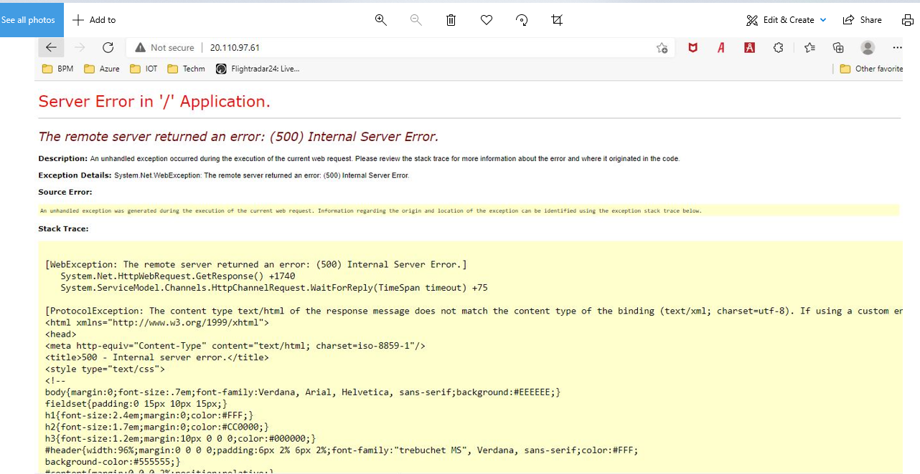

* + [Task 10: Post-migration steps](https://github.com/microsoft/MCW-Line-of-business-application-migration/blob/46a7040bc2f5f45eda2e66f229055f597657a9ee/Hands-on%20lab/HOL%20step-by%20step%20-%20Line-of-business%20application%20migration.md#task-10-post-migration-steps)
* [After the hands-on lab](https://github.com/microsoft/MCW-Line-of-business-application-migration/blob/46a7040bc2f5f45eda2e66f229055f597657a9ee/Hands-on%20lab/HOL%20step-by%20step%20-%20Line-of-business%20application%20migration.md#after-the-hands-on-lab)
  + [Task 1: Clean up resources](https://github.com/microsoft/MCW-Line-of-business-application-migration/blob/46a7040bc2f5f45eda2e66f229055f597657a9ee/Hands-on%20lab/HOL%20step-by%20step%20-%20Line-of-business%20application%20migration.md#task-1-clean-up-resources)